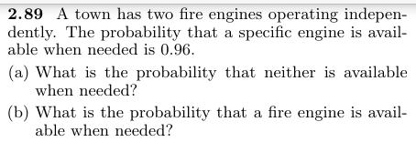
Solution:
P(A) = 0.96
P(B) = 0.96
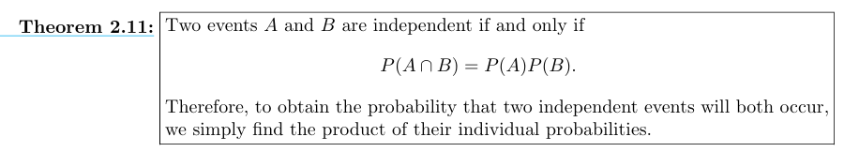

- P (neither is available when needed?)

$P(A^{'}∩B^{'})$=?

$∴P(A^{'}∩B^{'})$ = $P\left(A^{'}\right) P(B^{'})$

$∴P\left(A^{'}\right)=1-$P(A)

$$P\left(A^{'}∩B^{'}\right)=\left[1-P\left(A\right)\right][1-P\left(B\right)]$$
$$P\left(A^{'}∩B^{'}\right)=\left[1-0.96\right][1-0.96]$$

$$P\left(A^{'}∩B^{'}\right)=[0.04][0.04]$$

$$P\left(A^{'}∩B^{'}\right)=0.0016$$

- P (a fire engine is available when needed) ?

$$P\left(A∪B\right)=?$$
$∴P\left(A∪B\right)=1-P\left(A^{'}∩B^{'}\right)$
$P\left(A∪B\right)=1-0.0016$
$$P\left(A∪B\right)=0.9984$$
2.92
Suppose the diagram of an electrical system is as given in Figure 2.10. What is the probability that the system works? Assume the components fail independently.

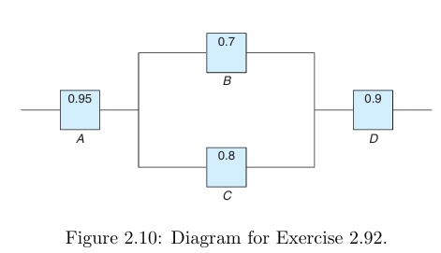
Solution:
Tow types circuit
1-Parallal
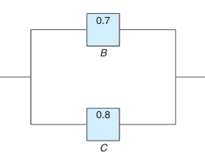
$$P\left(B∪C\right)$$

2-Series
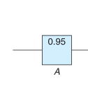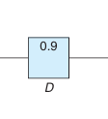
$$P\left(A∩D\right)$$

$$P\left(A∩\left(B∪C\right)∩D\right)= ?$$

$$P\left(A∩\left(B∪C\right)∩D\right)=P\left(A\right) P\left(B∪C\right) P(D)$$

$$∴P\left(A∪B\right)=1-P\left(A^{'}∩B^{'}\right)$$

$$P\left(A∩\left(B∪C\right)∩D\right)=P\left(A\right) [1-P\left(B^{'}∩C^{'}\right)] P(D)$$

$∴P(A^{'}∩B^{'})$ = $P\left(A^{'}\right) P(B^{'})$

$$P\left(A∩\left(B∪C\right)∩D\right)=P\left(A\right) [1-P\left(B^{'}\right) P\left(C^{'}\right)] P(D)$$

$$∴P\left(A∪B\right)=1-P\left(A^{'}∩B^{'}\right)$$

$$P\left(A∩\left(B∪C\right)∩D\right)=P\left(A\right) [1-\left[1-P\left(B\right)\right][1-P\left(C\right)] ] P(D)$$

$$P\left(A∩\left(B∪C\right)∩D\right)=(0.95) [1-\left[1-\left(0.7\right)\right][1-(0.8)] ] (0.9)$$

$$P\left(A∩\left(B∪C\right)∩D\right)=\left(0.95\right)\left[1-\left[\left(0.3\right)\right]\left[\left(0.2\right)\right]\right] \left(0.9\right)$$
$$P\left(A∩\left(B∪C\right)∩D\right)=\left(0.95\right)(0.94) \left(0.9\right)$$
$$P\left(A∩\left(B∪C\right)∩D\right)= 0.8037$$
2.93
A circuit system is given in Figure 2.11. Assume the components fail independently.
(a) What is the probability that the entire system works?
(b) Given that the system works, what is the probability that the component A is not working?
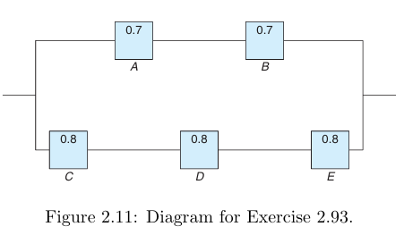
Solution:
- P(the entire system works) ?

$$P\left[\left(A∩B\right)∪\left(C∩D∩E\right)\right]= ?$$

$$∴P\left(A∪B\right)=1-P\left(A^{'}∩B^{'}\right)$$

$∴P\left(A^{'}\right)=1-$P(A)

$$P\left[\left(A∩B\right)∪\left(C∩D∩E\right)\right]=[1-P[{\left(A∩B\right)}^{'}∩({C∩D∩E)}^{'}]$$

$∴P(A^{'}∩B^{'})$ = $P\left(A^{'}\right)*P(B^{'})$

$$P\left[\left(A∩B\right)∪\left(C∩D∩E\right)\right]=[1-P\left[{\left(A∩B\right)}^{'}\right]* P[({C∩D∩E)}^{'}]]$$

$∴P\left(A^{'}\right)=1-$P(A)

$$P\left[\left(A∩B\right)∪\left(C∩D∩E\right)\right]=[1-[1-P\left[{\left(A∩B\right)}^{}\right]*[ 1-P[({C∩D∩E)}^{}]]]$$

$$P\left[\left(A∩B\right)∪\left(C∩D∩E\right)\right]=[1-[1-P\left(A\right)*P(B)]*[ 1-P\left(C\right)*P\left(D\right)*P(E)]]$$

$$P\left[\left(A∩B\right)∪\left(C∩D∩E\right)\right]=[1-[1-(0.7)(0.7)]*[ 1-(0.8)(0.8)(0.8)]]$$

$$P\left[\left(A∩B\right)∪\left(C∩D∩E\right)\right]=[1-[1-0.49]*[ 1-0.512]]$$

$$P\left[\left(A∩B\right)∪\left(C∩D∩E\right)\right]=[1-[0.51]*[ 0.488]]$$

$$P\left[\left(A∩B\right)∪\left(C∩D∩E\right)\right]=\left[1-\left[0.2488\right]\right]=0.75112$$

- P(the component A is not working) ?

$P=\frac{P(A^{'}∩ C ∩ D ∩ E)}{P\left(System works\right)}$

$$=\frac{(0.3)(0.8)(0.8)(0.8)}{0.75112}= 0.2045$$

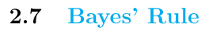
Total Probability
